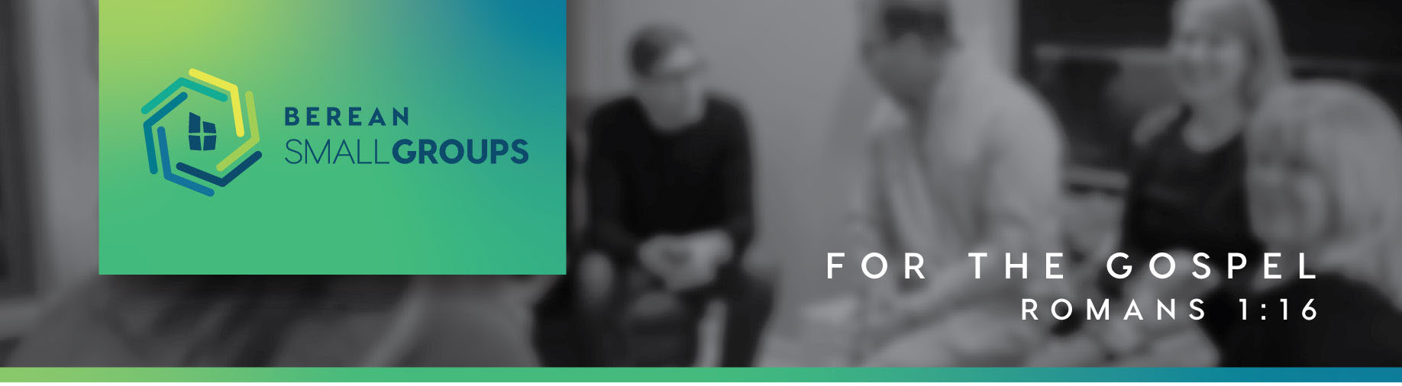

Living Here: Longing for Home
“Be the Blessing”

1 Peter 3:8-12
Finally, all of you, have unity of mind, sympathy, brotherly love, a tender heart, and a humble mind. ⁹ Do not repay evil for evil or reviling for reviling, but on the contrary, bless, for to this you were called, that you may obtain a blessing. ¹⁰ For “Whoever desires to love life and see good days, let him keep his tongue from evil and his lips from speaking deceit; ¹¹ let him turn away from evil and do good; let him seek peace and pursue it. ¹² For the eyes of the Lord are on the righteous, and his ears are open to their prayer. But the face of the Lord is against those who do evil.”

The Unfiltered Trash of our Past
- Are you still holding on to guilt from the past? What about unforgiveness? Bitterness? Anger? If the answer is no, look a little harder! Why do the events of the past hold so much power in the present and (possibly) future?

To see our lives, our community and our world be transformed by the power of the gospel.
-Berean’s Vision

- We’ve all been told that the cure for any ill is “Pray, read your bible, go to church.” Why could this advice sometimes make matters worse?
- Is our ability to get rid of the trash from past linked to our unbelief of the power of the gospel? Why or why not?

More than Words
- How does the Gospel transform practically in: (Think beyond PRYBGTC)

You keep him in perfect peace whose mind is stayed on you, because he trusts in you.

-Isaiah 26:3

      - Our lives? Our Community? Our world?
- How does the gospel show itself in a grace-and-truth marriage that requires a lot of work over a puppies and rainbows marriage?
- Which would better reflect the gospel in a relationship and why?
      - A perfect harmony or overcoming strife?

The Replacement Principle:

God never just says “no” without also saying “go.”

-Isaiah 26:3
1Pet. 2:1 So put away all malice and all deceit and hypocrisy and envy and all slander. ² Like newborn infants, long for the pure spiritual milk, that by it you may grow up into salvation— ³ if indeed you have tasted that the Lord is good.
- What does it mean to “taste” that the Lord is good? Why is this necessary in putting away sin? What happens to the power of the gospel in our minds when we struggle with unbelief?

How we can be a blessing to others -

Put on then, as God’s chosen ones, holy and beloved, compassionate hearts, kindness, humility, meekness, and patience, ¹³ bearing with one another and, if one has a complaint against another, forgiving each other; as the Lord has forgiven you, so you also must forgive. ¹⁴ And above all these put on love, which binds everything together in perfect harmony. ¹⁵ And let the peace of Christ rule in your hearts, to which indeed you were called in one body. And be thankful.

-Colossians 3:12-15
In The Gospel, put on:
- Unity of mind which replaces discord.
- Sympathy which replaces insensitivity.
- Brotherly love which replaces independence.
- Tender hearted which replaces callousness.
- Humble mind which replaces arrogance.

In the Gospel, put away
- Malice, deceit, slander, hypocrisy, envy and slander by growing up into salvation (1 Peter 2:2)
  - What does it mean to grow up into our salvation?
  - How can we help a brother or sister see they have some growing up to do without coming across as judgmental?

The Push motivation for blessing – Let me tell you:
“You shall not take the name of the LORD your God in vain,
for the LORD will not hold him guiltless who takes his name in vain. Exodus 20:7

- Why is it such an insult to take the Lord’s name in vain?
- What harm can it do to your own soul to be callous about the name of Jesus?
- Have you ever noticed that many will not pray in the name of Jesus Christ but they will use His name in cursing. Also notice people don’t curse the name of Mohammod or other gods. Why is this?

The Pull motivation for blessing - Let me show You:

For to this you have been called, because Christ also suffered for you, leaving you an example, so that you might follow in his steps. He committed no sin, neither was deceit found in his mouth. When he was reviled, he did not revile in return; when he suffered, he did not threaten, but continued entrusting himself to him who judges justly. 1 Peter 2:21-23

Blessing is our calling. But How do we do this?
- NO! Stop – Recognize your triggers, your former way of life.
  - If we’ve been transformed by Christ, why are we still blind to our personal triggers.
  - Why is it also hard to ask others to help you see when you’re being pulled away into your former way of life?
- Go! Start– Bless: saying thank you. Let me help. Change your tone of voice. Affirm & Celebrate.
  - How could we bring meaningful blessing to our small group right now?
- Repeat – Grow up into our salvation.

Matt. 5:38 “You have heard that it was said, ‘An eye for an eye and a tooth for a tooth.’ ³⁹ But I say to you, Do not resist the one who is evil. But if anyone slaps you on the right cheek, turn to him the other also. ⁴⁰ And if anyone would sue you and take your tunic, let him have your cloak as well. ⁴¹ And if anyone forces you to go one mile, go with him two miles. ⁴² Give to the one who begs from you, and do not refuse the one who would borrow from you. 43 “You have heard that it was said, ‘You shall love your neighbor and hate your enemy.’ ⁴⁴ But I say to you, Love your enemies and pray for those who persecute you, ⁴⁵ so that you may be sons of your Father who is in heaven. For he makes his sun rise on the evil and on the good, and sends rain on the just and on the unjust. ⁴⁶ For if you love those who love you, what reward do you have? Do not even the tax collectors do the same? ⁴⁷ And if you greet only your brothers, what more are you doing than others? Do not even the Gentiles do the same? ⁴⁸ You therefore must be perfect, as your heavenly Father is perfect. – Matthew 5:38-48

